JS Advanced: Exam 19 December 2016

Problems for exam preparation for the “JavaScript Advanced” course @ SoftUni. Submit your solutions in the SoftUni judge system at https://judge.softuni.bg/Contests/375/.

Problem 3. Player (Simple Class)

Write a JavaScript class Player.

class Player {
// TODO: implement this class
}

Each player holds nickname and list of scores . Implement the following features:

- Constructor(nickName) – creates a player with given nickname.

- Method addScore(score) – adds a score (as number) to the scores list. If passed argument is not a valid number or a string representation of a number, do nothing (ignore it).

- Accessor property scoreCount – returns the total amount of scores in the list.

- Accessor property highestScore – returns the highest score (number) in the list.

- Accessor property topFiveScore – gets the top 5 score (ordered descending), print all scores available if the score’s count is below or equal to 5.

- Method toString() – returns the text representation of the player in the following format:

o Player with only nickname:

{nickname}: []

o Player with several scores (e.g. 450 and 200), ordered by descending:

{nickname}: [450,200]

Examples

This is an example how the Player class is intended to be used:

Sample code usage

let peter = new Player("Peter"); console.log('Highest score: ' + peter.highestScore); console.log(`Top 5 score: [${peter.topFiveScore}]`); console.log('' + peter);
console.log('Score count: ' + peter.scoreCount);

peter.addScore(450); peter.addScore(200);
console.log('Highest score: ' + peter.highestScore);

console.log(`Top 5 score: [${peter.topFiveScore}]`); console.log('' + peter);

peter.addScore(2000); peter.addScore(300); peter.addScore(50); peter.addScore(700); peter.addScore(700);


© Software University Foundation (softuni.org). This work is licensed under the CC-BY-NC-SA license. Follow us:  Page 1 of 2
console.log('Highest score: ' + peter.highestScore);

console.log(`Top 5 score: [${peter.topFiveScore}]`); console.log('' + peter);

console.log('Score count: ' + peter.scoreCount);

console.log();

let maria = new Player("Maria")
.addScore(350)
.addScore(779)

.addScore(180);
console.log('Highest score: ' + maria.highestScore);

console.log(`Top 5 score: [${maria.topFiveScore}]`); console.log('' + maria);

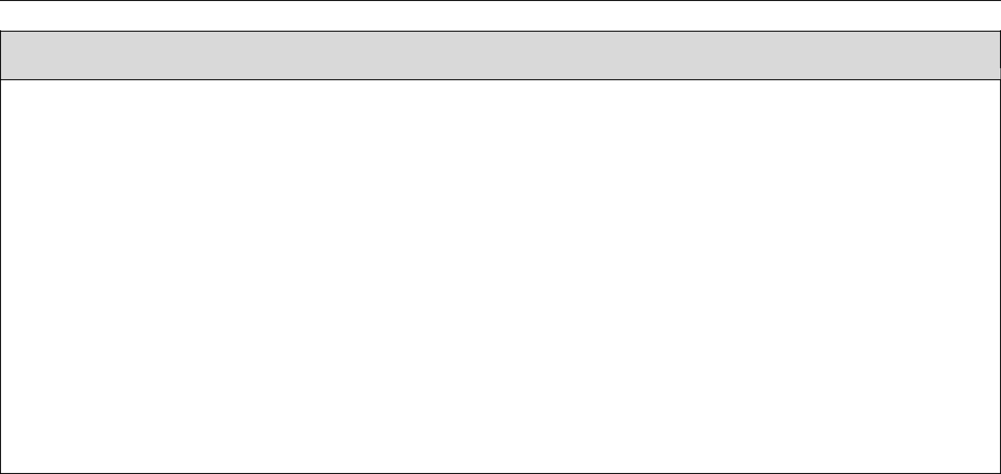

Corresponding output

Highest score: undefined

Top 5 score: []
Peter: []
Score count: 0

Highest score: 450
Top 5 score: [450,200]
Peter: [450,200]

Highest score: 2000
Top 5 score: [2000,700,700,450,300]
Peter: [2000,700,700,450,300,200,50]

Score count: 7

Highest score: 779

Top 5 score: [779,350,180]
Maria: [779,350,180]

Submission

Submit your class Player as “JavaScript code (Mocha unit tests) ”.

© Software University Foundation (softuni.org). This work is licensed under the CC-BY-NC-SA license. Follow us: Page 2 of 2

